|  |  |
| --- | --- |
|  | **Home Stay**  **Technical Design Document**  **1.0** |
| |  |  |  |  | | --- | --- | --- | --- | |  | **Prepared By / Last Updated By** | **Reviewed By** | **Approved By** | | **Name** | Gunjan Kumari | Syed Moosa Kadir | Syed Moosa Kadir | | **Role** | Programmer Analyst Trainee | Trainer | Trainer | | **Signature** | Gunjan Kumari |  |  | | **Date** | 24-01-2022 |  |  | |
|  |

Table of Contents

|  |  |  |
| --- | --- | --- |
| Sr. No | Description | Page No |
| 1.0 | **Introduction** | **3** |
| 1.1 | **Purpose of this document** | **3** |
| 1.2 | **Project overview** | **3** |
| 2.0 | **Solution Summary** | **3** |
| 2.1 | **Scope** | **3** |
| 2.2 | **Assumptions** | **3** |
| 2.3 | **Dependencies** | **3** |
| 3.0 | **Schematic Diagram** | **4** |
| 4.0 | **System Design** | **4** |
| 4.1 | **UI Validation** | **4** |
| 4.2 | **UI Design** | **6** |
| 5.0 | **Database Design** | **14** |
| 5.1 | **Data Model** | **14** |
| 5.2 | **Tables Structure** | **15** |
| 6.0 | **Terms and Conditions** | **18** |
| 7.0 | **Change Log** | **18** |

# Introduction

## Purpose of this document

The purpose of this document is to document the technical design, component details and database design of project Home Stay. This will also capture the scope, assumptions, risk, dependencies of this project.

## Project overview

*Home Stay is a lodging and tour service in India. The project aims at creating a platform for accumulating all the users – owners and customers. The owners can add/update their property available for lodging and the services provided along with. The customers can view/book home stay services as well as tour packages as per their required number of days and budget. The admin can provide technical help for website, like resolving help requests associated with the functional difficulties at the website pages. All the data is added and managed with a suitable database management system and the details validation is also taken care of.*

# Solution Summary

## Scope

* *Create and maintain user stories*

## Assumptions

* *Once the application is built, the Home Stay application will manually load the user list into the system*
* *There will be no concurrent users for the application. The user profile will be maintained by the Admin.*
* *Any changes to the design mentioned in the BRD would be taken as Change Request.*

## Dependencies

* *Availability and access of database design characteristics*
* *Resource availability throughout each sprint*

# Schematic Diagram

# System Design

## UI Validation

**User Registration:**

* *Clicking ‘Submit’ button should validate the datatype constraints for each field*
* *User failing to provide information for the mandatory fields be presented with an alert message – ‘Please update the highlighted mandatory field(s).’ Also, highlight the missed-out field in red.*
* *Upon saving the information in the database, display the message “New user created successfully”.*

**User Authentication:**

* *User ID and password are mandatory fields*
* *If User ID is not present, it should throw error saying " User ID not present.*
* *For wrong password, it should say "Password not matching".*

**Admin Credentials:**

* *When keyed in with correct credentials, it should log in.*
* *If Admin ID is not present, it should throw error saying " Admin ID not present.*
* *For wrong password, it should say "Password not matching"*

**Help:**

* *Date of ticket should be auto populated*
* *On submitting the Request ID should be auto generated and tagged to the ticket.*

**Resolve Help Request:**

* *Clicking on help request should list all the requests raised by the user.*

**Password reset/Retrieve User ID:**

* *When the user clicks Forgot User ID, system should ask for the secret questions, Contact number / email. On answering the questions correctly, the User ID should be displayed.*
* *When the user clicks Forgot Password, system should ask for the User ID and secret questions. On answering the questions correctly, the password reset page should be displayed.*
* *On entering the details in the password reset page, password should be validated*

**Add Home Stay Details:**

* *Clicking ‘Submit’ should validate the datatype constraints for each field.*
* *User failing to provide information on the mandatory fields be provided with an alert message – ‘Please update the highlighted mandatory field(s).’ Also, highlight the missed-out field in red.*
* *Upon saving the information in the database, display the message ‘Your details are submitted successfully’.*

**Home stay update:**

* *The updates done by user(owner) on details of his home stay should be validated.*
* *Update successful message should be displayed.*

**Tour Package Add/Update:**

* *Update successful message should be displayed.*

**Book stay:**

* *On clicking the homestay listed in search, it should display all the details. If the details match to his criteria, it should allow booking.*

## UI Design

**WEBSITE HOME PAGE**

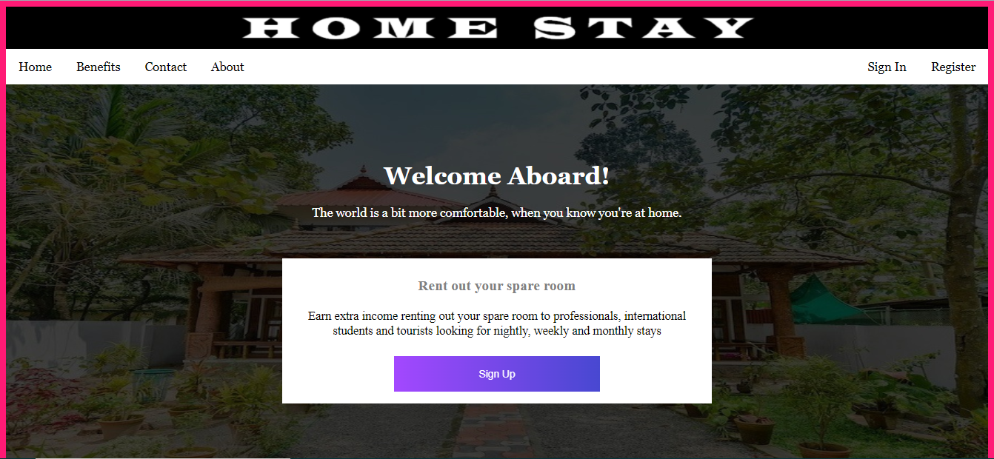

**NEW REGISTRATION**

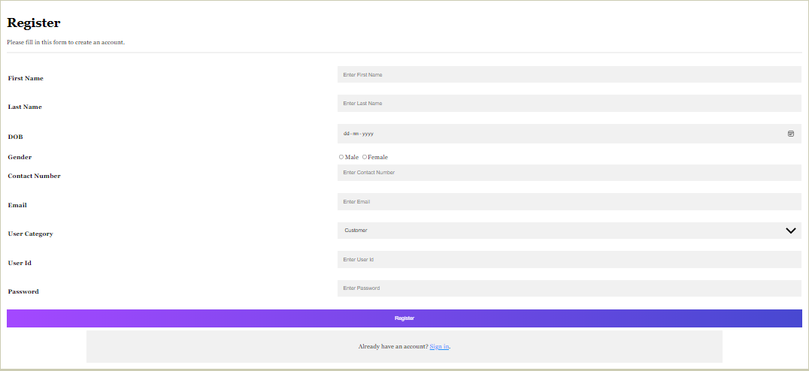

**LOGIN PAGE**

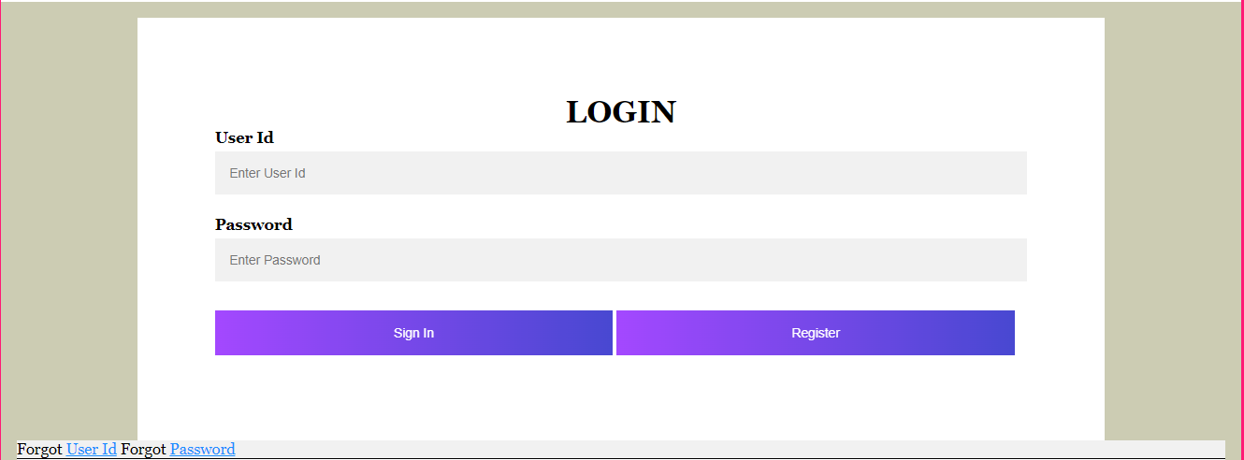

**TO RETRIEVE USER ID/PASSWORD**

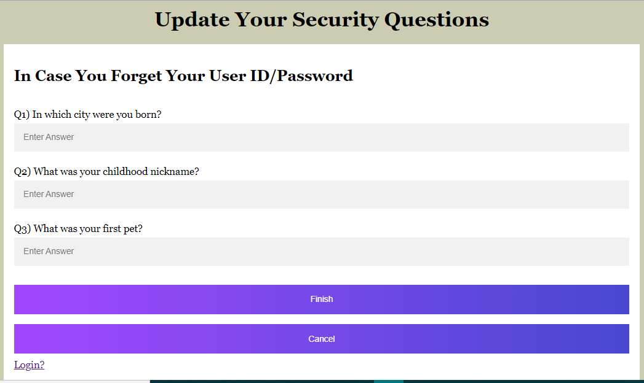

**ADMIN HOMEPAGE**

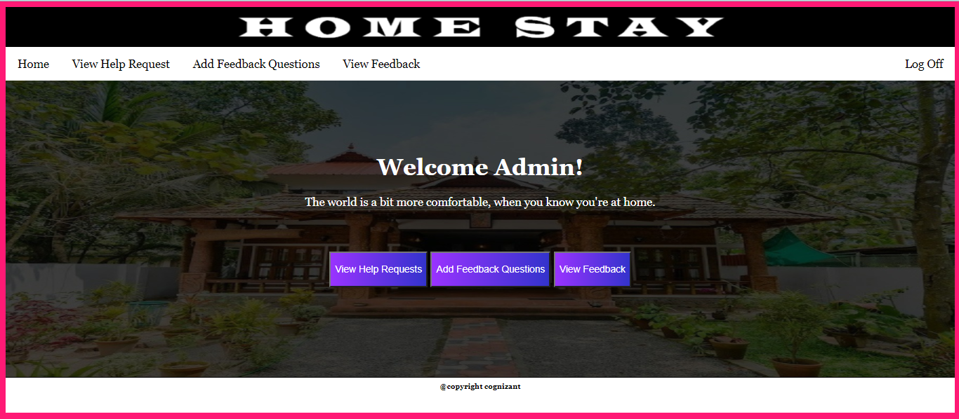

**HELP DESK – TICKETS**

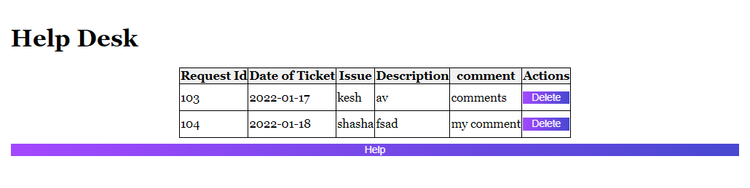





**USER (OWNER) HOME PAGE**

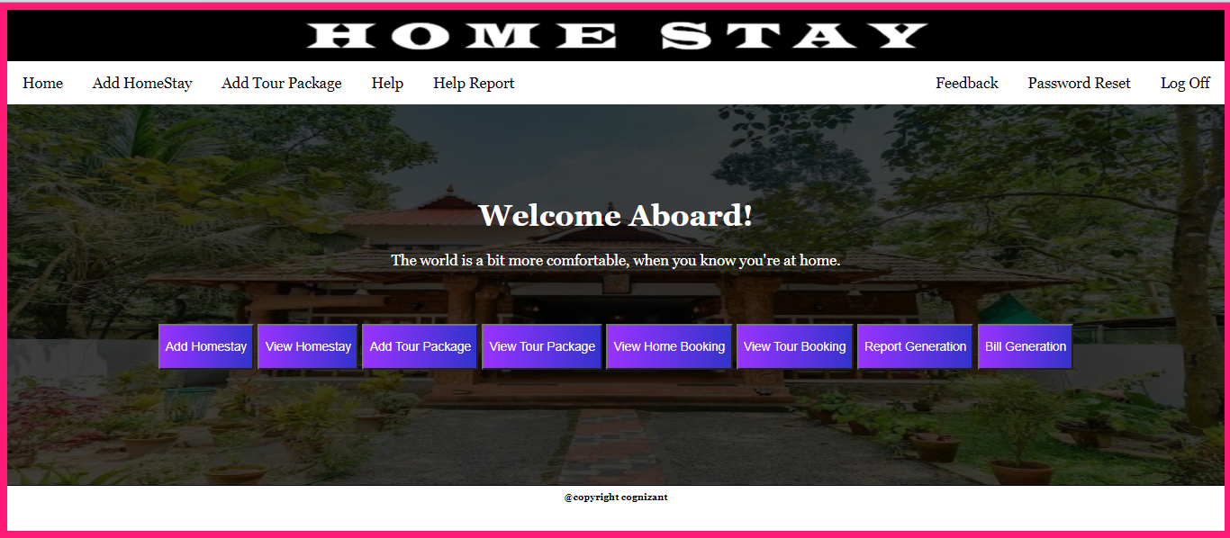

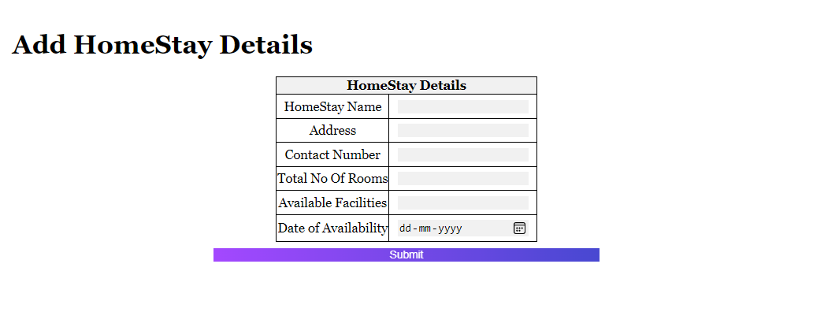

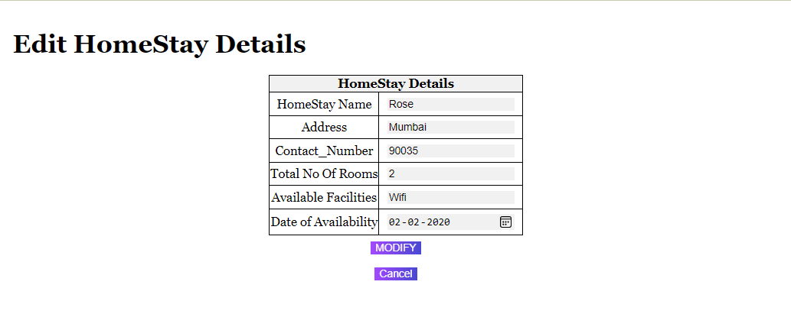

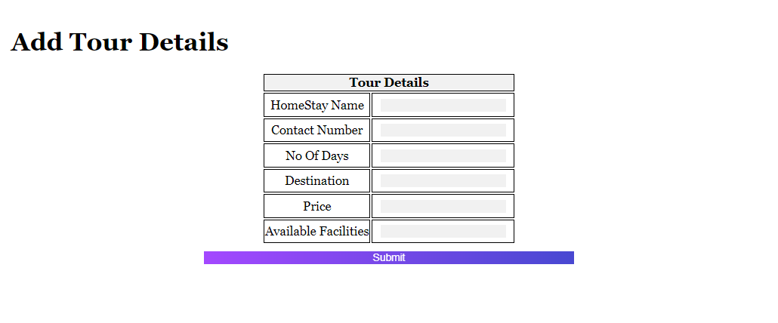

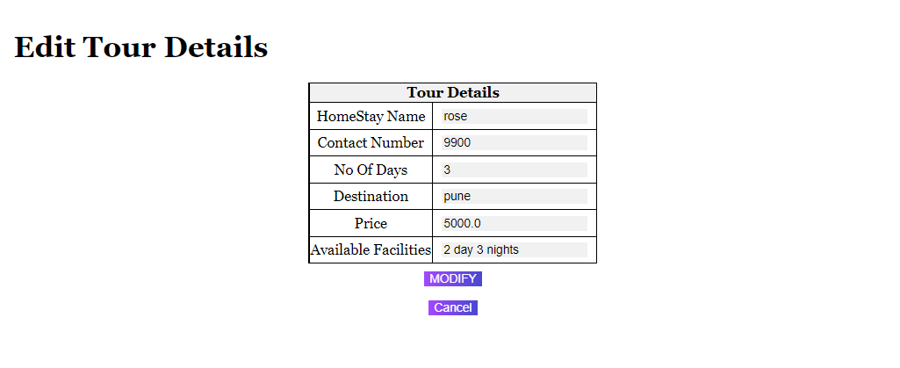

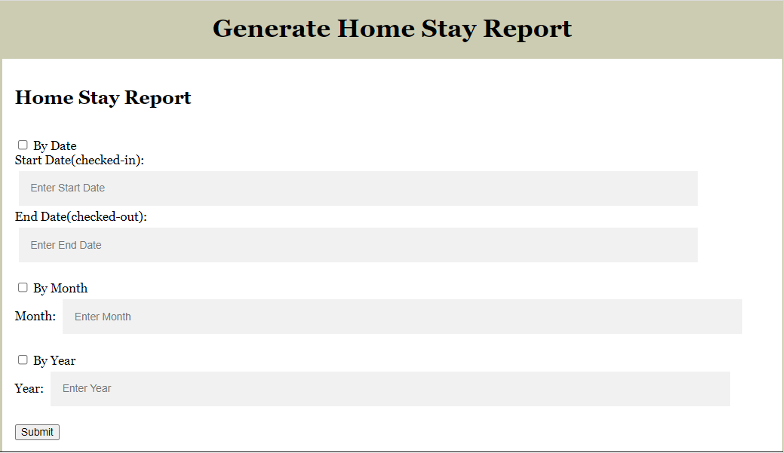

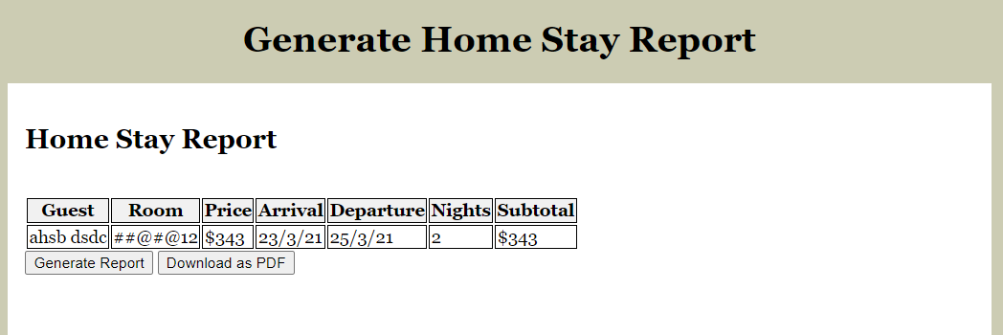

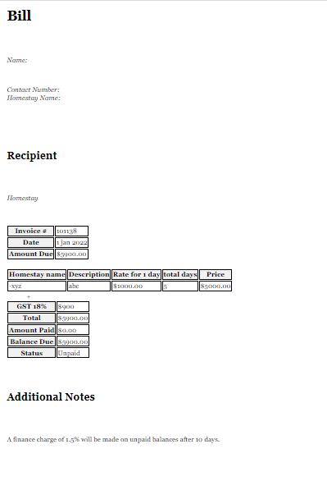

**USER (CUSTOMER) HOMEPAGE**

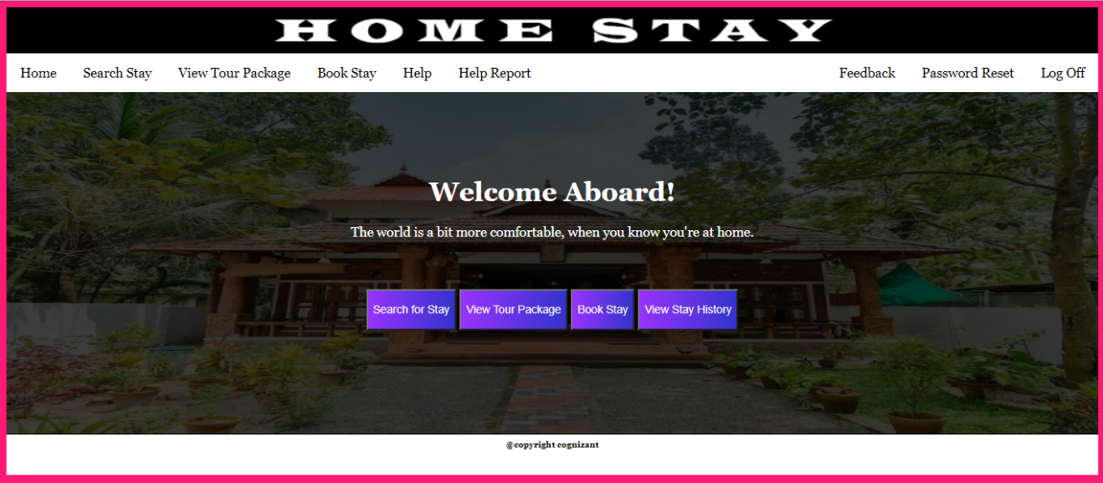

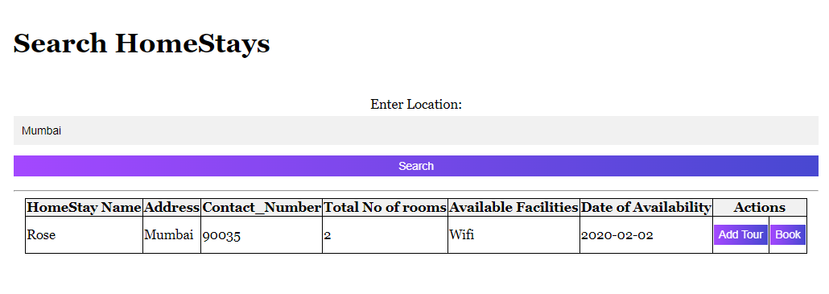

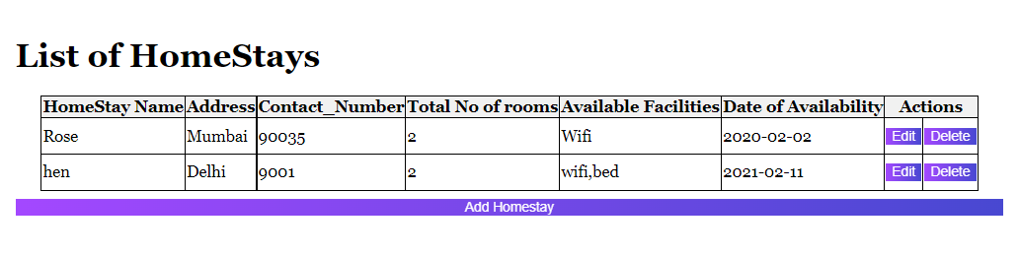

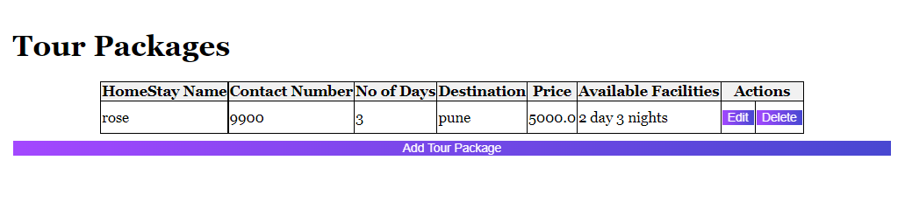

**HELP DESK – FORM**

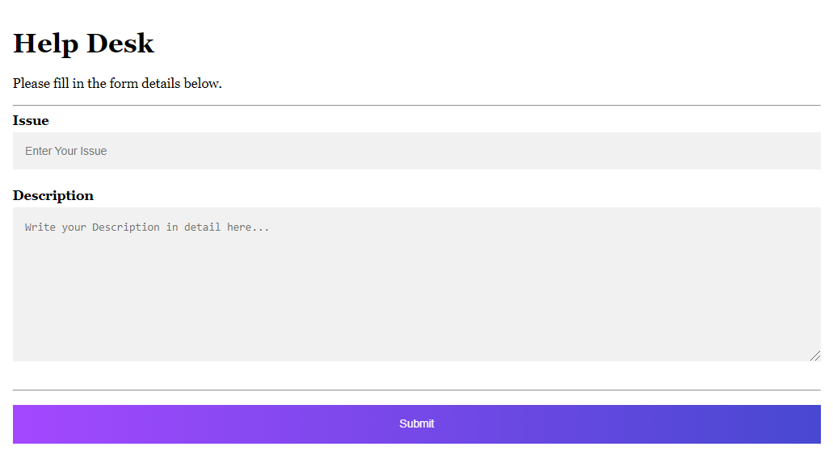

**For any technical difficulties, user (owner/customer) can raise a ticket at the Help Desk, which will be resolved by the admin.**

# Database Design

## Data Model

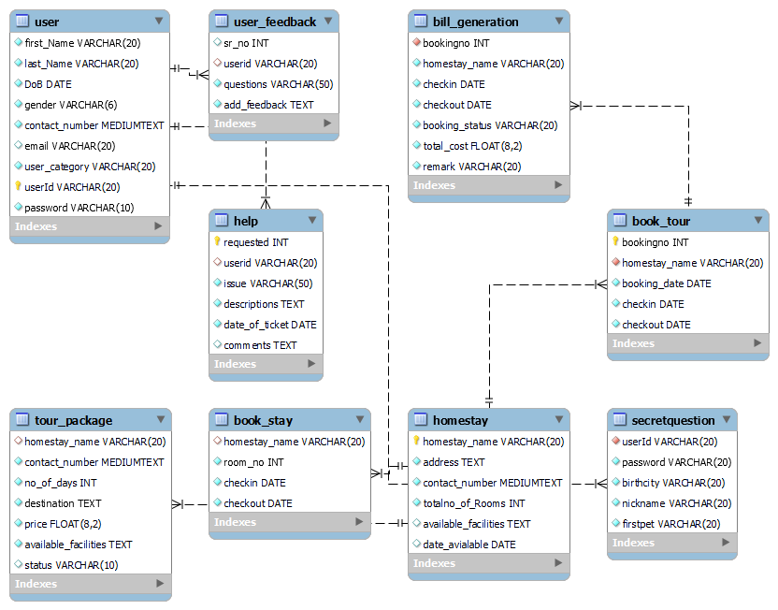

## Tables Structure

***user:***

|  |  |  |  |
| --- | --- | --- | --- |
| Column Name | Data Type | Length | Nulls |
| first_name  last_name  dob  gender  contact_number  email  user_category  userid  password | varchar  varchar  date  varchar  long  varchar  varchar  varchar  varchar | 20  20  -  6  10  20  20  20  10 | not null  not null  not null  not null  not null  not null  not null  not null  not null |

***home_stay:***

|  |  |  |  |
| --- | --- | --- | --- |
| Column Name | Data Type | Length | Nulls |
| homestay_name  address  contact_number  totalno_of_rooms  available_facilities  date_available | varchar  text  long  int  varchar  date | 20  250  12  2  250  - | not null  not null  not null  not null  not null  not null |

***help:***

|  |  |  |  |
| --- | --- | --- | --- |
| Column Name | Data Type | Length | Nulls |
| requested  userid  issue  descriptions  date_of_ticket  comments | Int  varchar  varchar  text  date  text | 3  20  50  250  -  250 | not null  not null  not null  not null  not null  null |

***tour_package:***

|  |  |  |  |
| --- | --- | --- | --- |
| Column Name | Data Type | Length | Nulls |
| homestay_name  contact_number  no_of_days  destination  price  available_facility  status | varchar  long  int  text  float  text  varchar | 20  12  2  250  8,2  250  10 | not null  not null  not null  not null  not null  not null  - |

***book_stay:***

|  |  |  |  |
| --- | --- | --- | --- |
| Column Name | Data Type | Length | Nulls |
| homestay_name  room_no  checkin  checkout | Varchar  int  date  date | 20  2  -  - | not null  not null  not null  not null |

***book_tour:***

|  |  |  |  |
| --- | --- | --- | --- |
| Column Name | Data Type | Length | Nulls |
| bookingno  homestay_name  booking_date  checkin  checkout | int  varchar  date  date  date | 5  20  -  -  - | not null  not null  not null  not null  not null |

***user_feedback:***

|  |  |  |  |
| --- | --- | --- | --- |
| Column Name | Data Type | Length | Nulls |
| sr_no  userid  questions  add_feedback | int  varchar  varchar  text | 3  20  50  250 | not null  not null  not null  not null |

***secretquestion:***

|  |  |  |  |
| --- | --- | --- | --- |
| Column Name | Data Type | Length | Nulls |
| userid  password  birthcity  nickname  firstpet | varchar  varchar  varchar  varchar  varchar | 20  20  20  20  20 | not null  not null  not null  not null  not null |

***bill_generation:***

|  |  |  |  |
| --- | --- | --- | --- |
| Column Name | Data Type | Length | Nulls |
| bookingno  homestay_name  checkin  checkout  booking_status  total_cost  remark | int  varchar  date  date  varchar  float  varchar | 5  20  -  -  20  8,2  20 | not null  not null  not null  not null  not null  not null  not null |

# Terms & Conditions

***Disclaimer: Please do not circulate or distribute this document outside of Cognizant Network, We have a Zero Tolerance Policy. Kindly adhere to 100% Compliance at all times.***

# Change Log

|  |  |  |  |  |
| --- | --- | --- | --- | --- |
| Version Number | Changes made | | | |
| V<1.0> | *<If the change details are not explicitly documented in the table below, reference should be provided here>* | | | |
| Page no | Changed by | Effective date | Changes effected |
| 3 | Gunjan | 10-01-2022 | Intro, Solution Summary |
| 4 | Gunjan | 11-01-2022 | Schematic Diagram |
| 12 | Musaddik, Gunjan | 12-01-2022 | Data Model (tentative) |
| 4,5,6 | Gunjan | 13-01-2022 | UI Validation |
|  | 12,13,14,15 | Gunjan | 17-01-2022 | Table Structure (tentative) |
|  | 12 | Musaddik, Gunjan | 18-01-2022 | Data Model (updated) |
|  | 6-11 | Keshav, Gunjan | 19-01-2022 | UI Design |
|  | 12,13,14,15 | Musaddik, Vishal | 20-01-2022 | Table Structure (updated) |
|  | 15,16 | Gunjan | 21-01-2022 | Table Structure (updated) |
|  | 11 | Gunjan | 21-01-2022 | UI Design (updated) |
|  | 2 | Pushpak | 24-01-2022 | Table of Contents |
|  | 10, 11 | Gunjan | 24-01-2022 | UI Design (updated) |